N8N Flow:

N8N Url: https://automation-nusa.innoark.com/home/workflows
User:
- To generate Work Order, run this:
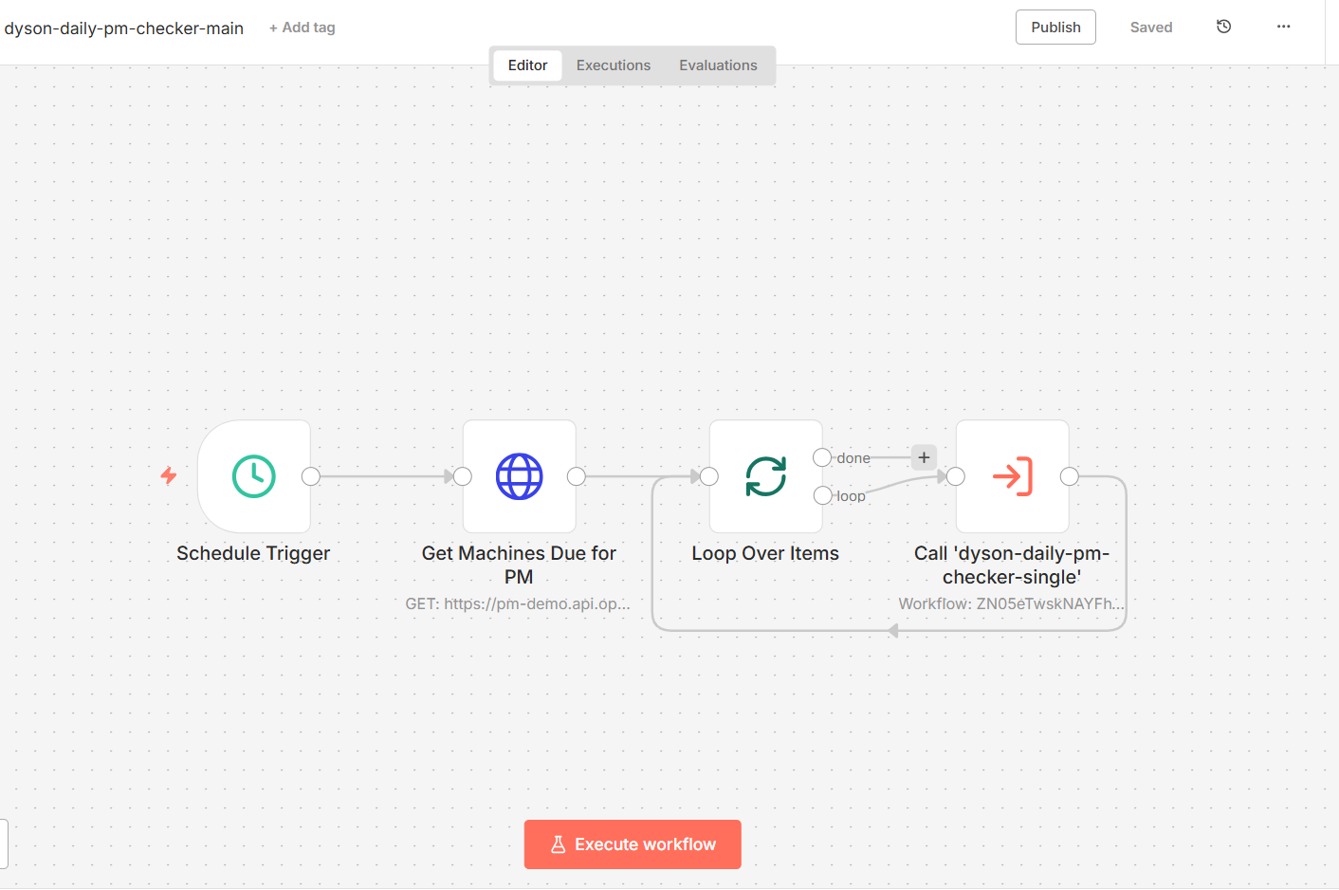

- Update Approve WO in the App
- It will send email notification, reply to the email

- Run this workflow to update based on the email
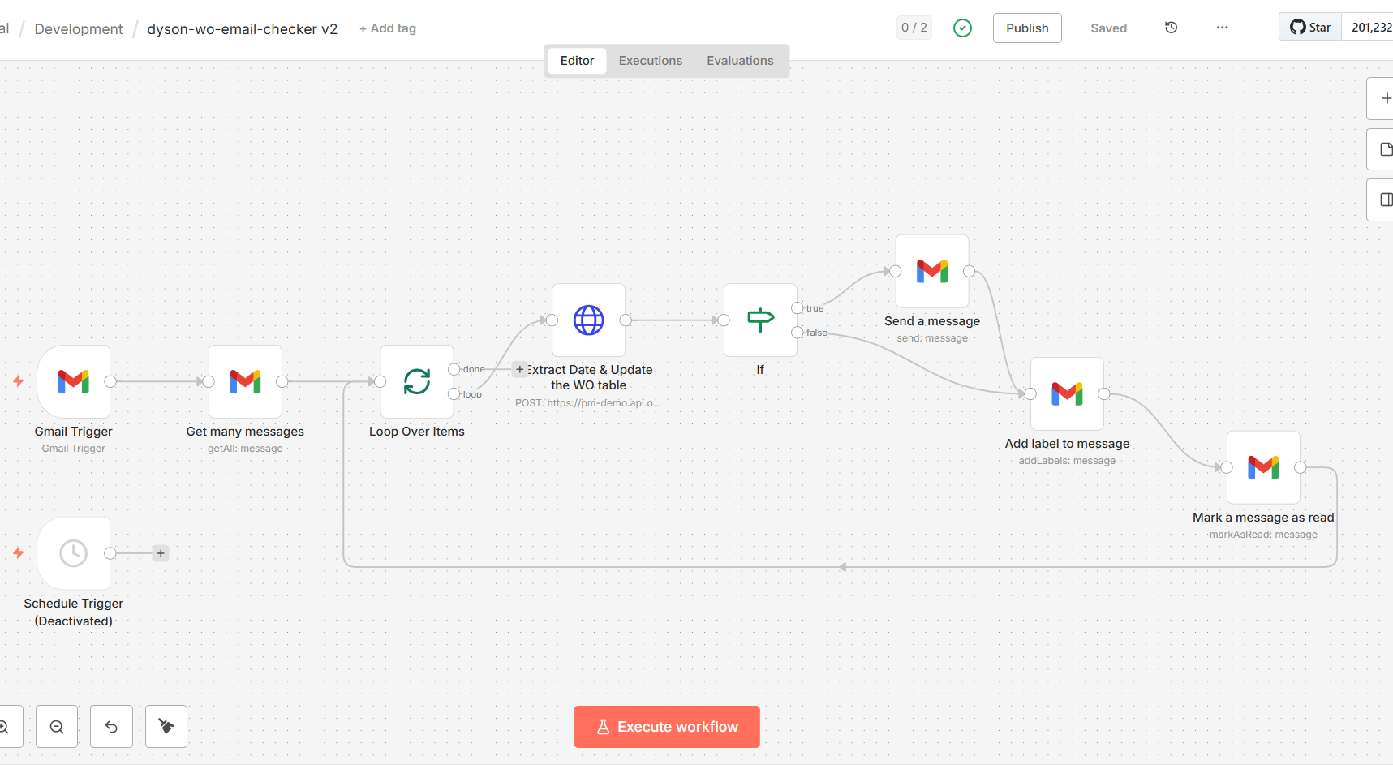

- Check the app, date that confirm in the email should appear in the form

